Comprehensive Interview Preparation Guide: Associate Director, Pharmacovigilance at Rocket Pharmaceuticals - Daniela Mitreva -Pehlivanova MD

I. Introductory Questions
- Can you tell us about your background and experience in pharmacovigilance and how it aligns with the role of Associate Director at Rocket Pharmaceuticals?
- What interests you most about joining Rocket Pharmaceuticals, particularly in the field of gene therapy and rare diseases?
- How do you see your previous leadership and medical expertise contributing to Rocket's mission of curing rare diseases?
- Given your recent career transition, how do you see Rocket Pharmaceuticals as a long-term professional home?
(Example Answer: I am eager to bring my expertise to an organization with a mission that aligns so closely with my professional values and goals. Rocket’s innovative gene therapy programs and collaborative culture are exactly what I’m looking for in the next chapter of my career.)

II. Competency-Based Questions
- Leadership in Safety Strategy
Describe a situation where you led a pharmacovigilance strategy to mitigate a major safety concern. How did you approach the situation, and what was the outcome?
- Cross-Functional Collaboration
Give an example of a time you worked with a diverse team to address a critical safety issue. How did you manage different personalities and communication styles?
- Regulatory Expertise
Tell us about a challenging experience preparing safety-related sections for regulatory submissions. What were the hurdles, and how did you overcome them?
- Signal Management
Describe a time when you identified and evaluated a new safety signal. What steps did you take to manage and mitigate the risks?
- Adaptability in a Dynamic Environment
Rocket’s entrepreneurial culture requires adaptability. Can you share an example of how you successfully navigated a rapidly changing situation?
- Process Improvement
Can you share an example where you improved pharmacovigilance processes? What specific actions did you implement, and what was the impact on compliance and efficiency?
- Presenting to Senior Leadership
Describe a time when you presented a safety strategy or critical update to executive leadership. How did you ensure clarity and alignment?

III. Technical/Skill-Based Questions
- Medical Causality Assessment
How do you approach assessing causality for adverse events in clinical trials? Can you provide a specific example?
- Safety Database Expertise
What is your experience using safety databases like Argus? How do you ensure accuracy and consistency in case reporting?
- MedDRA Coding
How do you ensure precise MedDRA coding in safety reporting? Share an instance where your coding decisions impacted safety signal detection.
- Aggregate Report Preparation
Explain your approach to reviewing or preparing aggregate reports like DSURs or PBRERs. How do you ensure completeness and alignment with global regulatory standards?
- Gene Therapy Safety Challenges
Gene therapies present unique safety challenges. How would you address these in pharmacovigilance planning and execution?

IV. Cultural Fit Questions
- Rocket values collaboration and innovation. Can you provide an example of a time you demonstrated these values in a high-stakes project?
- This role requires navigating complex personalities. How do you handle working with individuals who have different communication or decision-making styles?
- Rocket’s small, cross-functional teams require both collaboration and independent decision-making. How do you balance these two approaches in your work?
- How do you see your proximity to Cranbury, NJ, enhancing your ability to contribute effectively to Rocket’s mission?

V. HR-Related Questions
- Salary Expectation
What are your salary expectations for this role?
(Preferred Answer: My salary expectation is $220K, but I remain open to consideration of the total package.)
- Onsite Work Requirement
Are you open to working onsite three days a week as required for this role?
(Example Answer: Yes, I am fully open to the onsite requirement, as I understand its importance for collaboration and the role's responsibilities.)
- Role Commitment
How soon would you be available to start if selected for this position?
- Transition Readiness
How have you kept your skills sharp and relevant during your job search?
(Example Answer: I’ve stayed current by reviewing industry trends, regulatory updates, and attending webinars on pharmacovigilance in gene therapy. This has allowed me to deepen my understanding of cutting-edge therapies like Rocket’s programs.)
- Career Motivation
What motivates you to take on this role, and how does it align with your long-term goals?

VI. Follow-Up Questions
- Your CV highlights strong experience in device safety. How do you see this expertise applying to Rocket’s gene therapy focus?
- In your previous role, you reduced reporting delays for SUSARs. Could you elaborate on how you achieved this and its implications?
- You’ve co-chaired cross-functional safety meetings. Can you discuss a particularly challenging meeting and how you facilitated consensus?
- Your work in medical safety monitoring includes therapeutic areas like immunology and neuroscience. How do you adapt to new therapeutic areas like cardiovascular or rare genetic disorders?
- Could you explain the impact of your involvement in process improvements for pharmacovigilance operations, particularly on compliance or efficiency?

VII. Candidate’s Questions
Encourage thoughtful questions to demonstrate alignment with Rocket’s mission:
- What are Rocket’s current challenges in pharmacovigilance, and how can I contribute to overcoming them?
- How does Rocket support professional development, particularly in emerging fields like gene therapy?
- What opportunities are there for cross-functional collaboration, particularly with teams working on regulatory and clinical development?
- How does Rocket plan to scale its safety processes as its pipeline grows?
- What role does this position play in achieving Rocket’s regulatory milestones and clinical development goals?

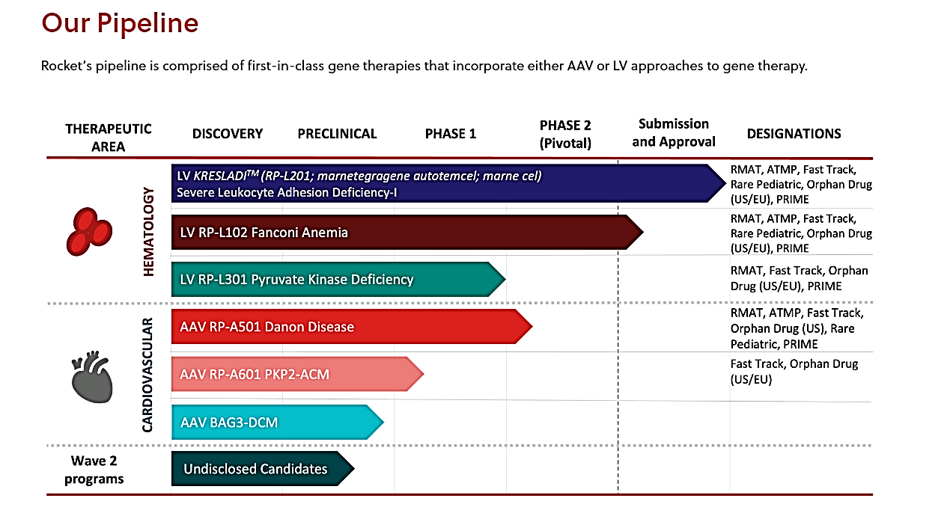

Hematology

Fanconi Anemia (FA)
FA is a rare genetic disorder affecting DNA repair. Approximately two-thirds of FA cases are caused by genetic defects in the FANCA gene, which results in the FA subtype known as FA Complementation Group A (FA-A). FA patients may develop bone marrow failure (very low blood counts), cancers of the blood or other cancers.
RP-L102 is a gene therapy product containing autologous (patient-derived) hematopoietic stem cells (HSCs) that have been genetically modified with a lentiviral vector to contain a functional copy of the FANCA gene. If given early in life, RP-L102 gene therapy has the potential to serve as a preventative measure, correcting bone marrow cells before there is progression to severe bone marrow failure.

Leukocyte Adhesion Deficiency (LAD-I)
LAD-I is a rare genetic disorder affecting the immune system and is caused by a defect in the ITGB2 gene, leading to a deficiency in CD18. Due to this deficiency, white blood cells (primarily neutrophils) are unable to leave the bloodstream to go to sites of infection or inflammation. As a result, patients with severe LAD-I can develop life-threatening infections which they are unable to fight. Without a successful bone marrow transplant, survival beyond childhood is rare.
RP-L201 is a gene therapy product containing autologous (patient-derived) hematopoietic stem cells (HSCs) that have been genetically modified with a lentiviral vector to contain a functional copy of the ITGB2 gene.
Pyruvate Kinase Deficiency (PKD)
PKD is a rare genetic blood disorder. PKD is caused by a defect in the PKLR gene which is responsible for energy production in red blood cells (RBCs). RBCs carry oxygen to the rest of the body. When the PKLR gene has a defect, RBCs are limited in their ability to produce energy and remain intact. As a result, patients with PKD frequently have anemia, chronic fatigue, yellowing of the skin and eyes (jaundice) and enlarged spleens.
RP-L301 is a gene therapy product containing autologous (patient-derived) hematopoietic stem cells (HSCs) that have been genetically modified with a lentiviral vector to contain a functional copy of the PKLR gene. RP-L301 has the potential to correct multiple disease elements associated with PKD. Due to the number of patients who could benefit from RP-L301, Rocket’s PKD program has the potential to become its largest lentiviral vector program

Cardiovascular
Danon Disease
Danon Disease is a rare genetic disorder that is characterized by severe and primarily hypertrophic cardiomyopathy. Skeletal muscle weakness and mild cognitive impairment are also common. The causative mutation has been identified in the gene encoding for lysosome-associated membrane protein (LAMP2), and in particular the LAMP2B version of the gene which is primarily expressed in heart, skeletal muscle and brain tissue. Affected cells cannot efficiently digest and recycle protein and other materials, leading to dysfunction in heart, muscle and brain cells.
RP-A501 is a gene therapy product consisting of a recombinant adeno-associated serotype 9 (AAV9) capsid containing a functional version of the human LAMP2B transgene (AAV9.LAMP2B) which is administered as a single intravenous (IV) infusion. RP-A501 has the potential to restore normal cardiac function in patients with Danon Disease.
PKP2 ACM
PKP2 arrhythmogenic cardiomyopathy (ACM), also known as ARVC or ARVD, is a high-risk cardiomyopathy caused by autosomal dominant mutations in the PKP2 gene. ACM is characterized by frequent and life-threatening ventricular arrhythmias and structural ventricular myopathy. Available treatments fail to address the underlying genetics and disease biology and do not alter disease progression.
RP-A601 is an investigational gene therapy consisting of a recombinant adeno-associated serotype rh74 (AAVrh74) capsid containing a functional version of the human PKP2 transgene (AAVrh74.PKP2) which is administered as a single intravenous (IV) infusion.
BAG3-Associated DCM
BAG3-associated dilated cardiomyopathy (DCM) is a rare genetically driven form of heart failure caused by mutations in the BAG3 gene. BAG3 protein is expressed predominantly in the heart, where it has multiple functions within the cell due to the presence of multiple protein binding sites. BAG3 protein has roles in sarcomere maintenance, normalization of protein quality control, inhibition of programmed cell death, and responsiveness to adrenergic signals. Because BAG3 plays a role in multiple critical myocardial cell functions, we believe gene therapy offers unique potential to directly restore proper cellular function. The preclinical program was acquired by Rocket through the acquisition of Renovacor, completed in December 2022.

